INSTITUTE OF NATURAL TRADITIONAL AND INTEGRATIVE MEDICINE

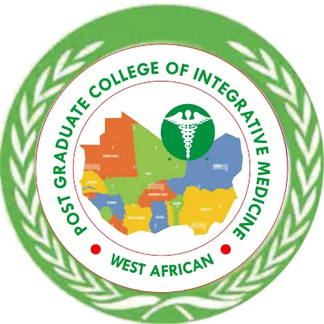

Structured Certification Framework in CAM
(Enhanced with Hours & Credits)

Structured Certification Framework in CAM (Enhanced with Hours & Credits)

1. PROFESSIONAL CERTIFICATE IN TRADITIONAL COMPLEMENTARY ALTERNATIVE MEDICINE/INTEGRATIVE MEDICINE
Duration:
6 months
Training Intensity:
(4–6 hours daily: 3 hrs lecture/practical + 1–3 hrs self-study)
Credit Load:
12–18 credit units total
1 credit = 15 contact hours

2. PROFESSIONAL DIPLOMA IN TRADITIONAL COMPLEMENTARY ALTERNATIVE MEDICINE/INTEGRATIVE MEDICINE
Duration:
1-2 year
Training Intensity:
(5–7 hours daily: 3–4 hrs lectures + 2–3 hrs practical/clinical/self-study)
Credit Load:
30–36 credit units

3. ADVANCED DIPLOMA/HIGHER DIPLOMA IN TRADITIONAL COMPLEMENTARY ALTERNATIVE MEDICINE/INTEGRATIVE MEDICINE
Duration:
1–2 years
Training Intensity:
(6–8 hours daily: 3–4 hrs lectures + 3–4 hrs clinical/practical/research)
Credit Load:
40–60 credit units

4. GRADUATE/POSTGRADUATE DIPLOMA IN TRADITIONAL COMPLEMENTARY ALTERNATIVE MEDICINE/INTEGRATIVE MEDICINE
Duration:
Duration:
1–2 years
Training Intensity:
(6–8 hours daily: 3–4 hrs lectures + 3–4 hrs clinical/practical/research)
Credit Load:
40–60 credit units

5. PROFESSIONAL MASTER’S IN TRADITIONAL COMPLEMENTARY ALTERNATIVE MEDICINE/INTEGRATIVE MEDICINE
Duration:
2 years
Training Intensity:
(7–9 hours daily: 3–4 hrs lectures + 3–5 hrs clinical/research work)
Credit Load:
60–72 credit units
Breakdown:
Coursework: 36–48 credits
Clinical/Residency: 12–18 credits
Thesis: 6–12 credits

6. DOCTORATE (DCM – Doctor of TRADITIONAL COMPLEMENTARY ALTERNATIVE MEDICINE/INTEGRATIVE MEDICINE SPECIALTIES)
Duration:
3–5 years
Training Intensity:
(8–10 hours daily: research, clinical practice, teaching)
Credit Load:
72–90+ credit units (mostly research-based)
Breakdown:
Advanced coursework: 12–24 credits
Research/Dissertation: 40–60 credits
Clinical/Residency: 12–18 credits

7. FELLOWSHIP IN TRADITIONAL COMPLEMENTARY ALTERNATIVE MEDICINE/INTEGRATIVE MEDICINE INTEGRATIVE MEDICINE (FICM)
Duration:
3 years
Training Intensity:
(6–8 hours daily: advanced clinical + leadership + mentorship)
Credit Equivalent:
Not always credit-based
Competency & portfolio-based certification

STANDARD CREDIT SYSTEM (VERY IMPORTANT)
To make it look university-standard, include this:
Credit Unit Definition:
1 Credit Unit =
15 hours Lectures OR
30 hours Practical/Clinical OR
45 hours Research/Independent Study

SAMPLE WEEKLY STRUCTURE (WHAT THEY EXPECT TO SEE)
Instead of saying 18 hours daily, show structure:
Typical Week (MSc or PGD):
Lectures: 15–20 hours/week
Clinical Practice: 15–25 hours/week
Self-study/Research: 10–20 hours/week
Total: 40–60 hours/week (globally accepted standard)

